MOVIE RENTAL SYSTEM

Harsha Srivatsav Arra, Dr. Roger Lee, Dr. Patrick Kinnicutt

Department of Computer Science

Central Michigan University, Mount Pleasant, MI

arra1h@cmich.edu, lee1ry@cmich.edu, kinni1p@cmich.edu

Abstract—Traditional Movie Rental Systems are long gone and their new replacement is long overdue. With the moving digital world, there is definite need for more advanced movie rental system. The online rental system presents an online display of an order cut off time and an associated delivery window for items selected by the customer. When ordering movies, this rental system provides a virtual shopping cart for holding items selected for purchase. Successive items selected for purchase are placed into the virtual shopping cart until a customer completes their movies list. Virtual shopping carts may be examined at any time, and their contents can be edited or deleted at the option of the customer. Once the customer decides to submit a purchase order, the customer pays the amount for the transaction and logs out of the system. [1]

Index Terms—e-commerce, movie rental, online shopping, web application.

I. INTRODUCTION
eb applications are any applications that uses a website as an interface(the ‘front-end’). These are growing at a rapid pace and are ruling the roost(internet) today. Renting a movie using a traditional movie rental system is very time consuming, unreliable and old fashion. Digitization of old movie rental system is long awaited. Users should have a pleasant shopping experience while shopping movies. A hassle free pure shopping experience should be delivered to the customers. Here, users can search for movies based on various parameters such as Movie Name, Cast, Director etc. and can add the movies to the shopping cart and can checkout and pay the money to complete their
W
transaction.

II. MODULES DESCRIPTION
The Movie Rental has a wide range of modules that are

used in providing the functionality of the system. Explanation of these modules will help understand the system better.

A. Login Module:
This module comes under Authentication Segment of the project and plays a crucial role in allowing valid users into the system. When the user enters his/her username and password, the combination is verified with that of the data present in the database. If the combination is correct, he/she will be granted access to the system. If not, the system throws error stating that the username or password is wrong.

B. Register Module:
If any new user wants to purchase movies from the movie rental system, he/she should create an account. Once they create an account, they will be automatically logged into the system. Thereby can perform various transactions.

C. Admin Module:
Admin is the super user of our movie rental system. He holds a plethora of super user privileges. He can add movies, remove and update them. He can revoke any user from the system.

D. Movies Module:
Here in this module, admin will add movies into the backend database. The information for the movies module has been taken from IMDB and YouTube. The fields that comprises the Movie Module are Name, Cast, Director, Genre, Year, Plot, Trailer, Poster, Rating and Price.

E. Cart Module:
Once the users select the movies, they can add them to the shopping cart. They can use the cart to hold the

movies they have selected to purchase. This is a virtual cart and not a physical cart. Once the user decided to checkout, the payment module loads up.

F. Payment Module:
After the user checks out of the cart, a payment page loads up asking to enter valid credit card details and once the user enters the details and hit pay button, the transaction will be performed and a successful transaction message appears on the screen.

G. Search Module:
The use of this module is to search for the movies based on various parameters such as Name, Cast, Genre etc. For example, if the user wants to check whether there is a Spiderman movie in the system, he then types spider into the search box provided. If there is a movie named Spiderman or any movie that has the word
‘spider’ in its name, the movie will pop up as a filtered
result.

H. News Module:
This is an add-on module provided for more functionality of the system. If any user wants to check the latest Hollywood news, he can click the news icon on the system. Upon clicking, the system grabs news from various sources and displays the news on the site.

I. Movie Tickets Module:
This is also an add-on module implemented into the system. If the user wants to know what all movies are currently being displayed in the theaters, he is just a click away. The system takes him to the current list of movies in the theaters. Further clicking of the movie takes him to the tickets page where he can book the movie tickets of his choice.

J. Logout Module:
This module comes under Authentication Segment of the project and plays a crucial role in closing the sessions opened by users when they logged in. When the user hits Logout icon in the site, the system will kill the session variables that have been created in the session. Once the user logs out, he cannot login into the system until he provides his username and password. This is a very important module as it prevents hackers from getting access to the system.

III. BACKGROUND STUDY

A. Online Shopping
The act of purchasing products or services over the
Internet. Online shopping has grown in popularity over
the years, mainly because people find it convenient and easy to bargain shop from the comfort of their home or office. One of the most enticing factor about online shopping, particularly during a holiday season, is it alleviates the need to wait in long lines or search from store to store for an item. [2]
It is the process consumers go through to purchase products or services over the Internet. An online shop, e- shop, e-store, internet shop, web shop, webstore, online store, or virtual store cause the physical analogy of buying products or services at a bricks-and-mortar retailer or in a shopping mall. [3] Customers make purchases to satisfy needs. So, we must give them a platform so user-friendly and interactive that they have a pleasant experience shopping for products they like.

B. Web Application
An application in which all or some parts of the software are downloaded from the Web each time it is run. It may refer to browser-based apps that run within the user's Web browser, or to "rich client" desktop apps that do not use a browser or to mobile apps that access the Web for additional information. In a browser-based Web application, JavaScript instructions are contained within the Web page that is retrieved from a Web site. Combined with the HTML code that determines the visual layout and the CSS style sheet, the HTML, JavaScript and CSS are executed via the browser. In addition, processing at the server side is often widely performed to access databases and other networks. The data for a Web application may be stored locally or on the Web, or in both locations. [4]

IV. METHODS

A. An Overview of Existing System:
The existing system has a fair share of its disadvantages up its sleeve. In Existing System, to buy or rent a movie, user must collect information about it either by visiting any movie store which is time consuming. Secondly, maintaining a traditional movie rental system is expensive. Also, it has very less privileges for the person operating a movie rental system. More importantly, Data Threat and Security is a primary concern. Some more risks are identity theft, false advertising, and damaged items or false. You have to struggle your way through crowds of jostling people, wait in queues to make your purchase, and you usually have to go from one store to another to find some item you may be looking for.

And that is one of the main problems of a traditional shop. Usually, if you are looking for a item, you will

find only limited choices of it. Having a limitation of shelf space, brick and mortar shops simply cannot afford to provide large varieties of products. For them, it makes economic sense to fill the limited space on their shelves with items that sell most. These products may not necessarily be the best, but probably are the ones that are marketed the best. [5]

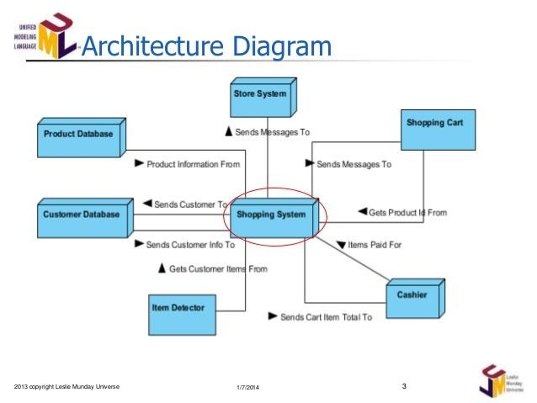B. Architecture:
enough to pay for a few items or gifts you were thinking of buying.

Online shopping saves precious time. With the busy lives that most of us lead these days, anything that saves time is a boon. When you shop online, it will take you about a minute to log on to the Internet, about a minute or two more to access the website of the store of your choice, it may take another ten to fifteen minutes to select the items you want to buy, and about five minutes more to fill in the information about your payment and get a print out of your receipt. Voila! It would take you just about thirty minutes to do your shopping. Imagine all the things you could do with all the time saved, like spending quality time with the kids, or perhaps even catching the movie you have been meaning to see.

Online shopping offers a sense of ease and comfort; as opposed to trudging all through the high-street hunting for the things you want. You can truly understand the difference between online vs. traditional shopping when you step into a brick and mortar shop, especially during holiday shopping season. You have to struggle your way through crowds of jostling people, wait in queues to make your purchase, and you usually have to go from one store to another to find some item you may be looking for. [8]

Fig: Existing System Architecture [7]

From the above architecture, we can say that it is time consuming and not cost effective to set up a traditional (in-store) shopping system.

C. An Overview of Proposed System:
The Proposed System is an Online Shopping System in contrast to traditional shopping system. Proposed System provides a flexible password storage system and uses PBKDF2(Password-Based Key Derivation Function
2) which provides an immense security to the Users Data. In proposed system, we are providing a dedicated admin panel and super user privileges powered admin to control all users in the system. The proposed system is very much cost effective. It is User friendly. It needs very minimum time to perform a transaction and it is very responsive.

One of the main advantages of shopping online is the elimination of the need to drive somewhere to buy something. So, no frustrations of dealing with traffic snarls and no parking problems. Besides, you could use up half your petrol merely shopping for the stuff you want. With the price of petrol being what it is these days, the money you save by shopping online will often be

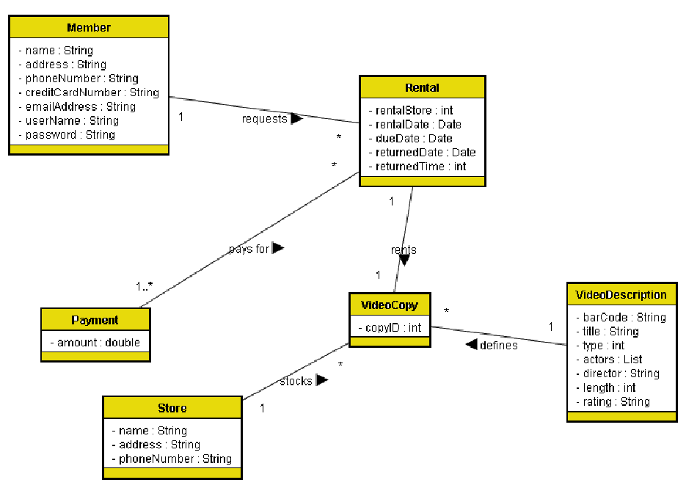

Fig: Proposed System Architecture [9]

D. Explanation of System Architecture:
End User opens the Website. If he hasn’t registered, he must register and then can log into the system. If the user has already registered, he can directly log in to the system. Upon getting into the system, user can search for movies based on various parameters such as Movie Name, Genre, Cast etc. He then can select movie and can add to cart. The cart is a virtual cart and it lives in the session. So, as long as the user is logged in, the cart values stay alive. After selecting the movies, he can review the cart and checkout. Finally, he pays the amount and can continue the shopping or can logout of the system.

This proposed system architecture has so many advantages over the existing system. It is cost effective, needs less manpower, very responsive and dynamic.

E. Develop Algorithm:
To run an online shopping system, we have to come up with an algorithm that best runs and suits the system.

#User enters username and password

If username matches password
Allow user
Else
Return to login page

If user is not registered
Register user
Else
Login()

#After Logging In

Search for movies If search is valid Connect to database Retrieve data Display results
Else
Throw an error

#Selecting a movie

Select a movie based on cast, director, name
Add to Cart
If shopping is over
Checkout from the cart
Else
Continue Shopping
Logout
F. Implement Algorithm:
As you can see from the algorithm, the user enters his username and password. If the combination is correct, he will be allowed into the system. If not, the system throws an error. If the user is not a registered user, then he has to register first and he will gain access into the system.

After logging in, the user can search for movies based on various parameters such as movie name, cast, director, genre etc. Once he enters the query and hit search, the system will connect to the database and retrieve the results and the system will display the results. If the search is not valid, means if the user enters special characters and irrelevant information, then the system will throw an error on the screen.

So, once the user selects a movie, he can add it to the cart and checkout from the cart and can pay the amount through credit or debit card.

If the user is done with the shopping, he can logout from the system. Or, if he wants to continue shopping, he can continue to do so and can logout from the system later.

V. TESTING AND RESULTS
In this section, we will test each module described above and display the results for each testing.

A. LOGIN:
If the user enters invalid credentials and hit sign in,

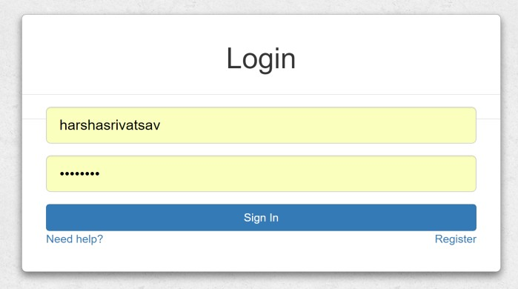
Fig: Login

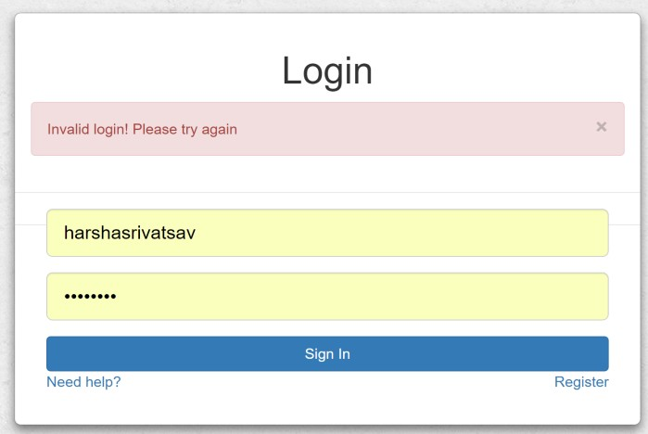Fig: Invalid Login

C. SELECTING A MOVIE AND ADDING TO CART:
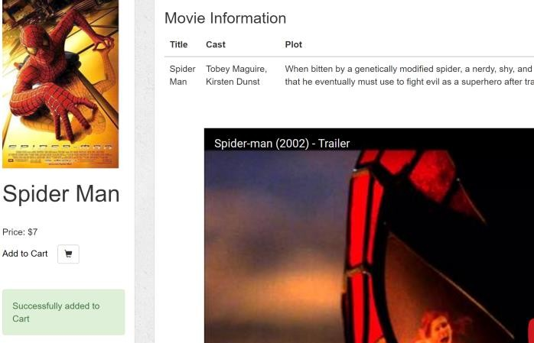User selects a movie and adds it to the cart.

B. SEARCH FOR A MOVIE:
Users enters the search term and hit Search for the filtered results.

D. CHECKOUT:
Fig: Adding to Cart
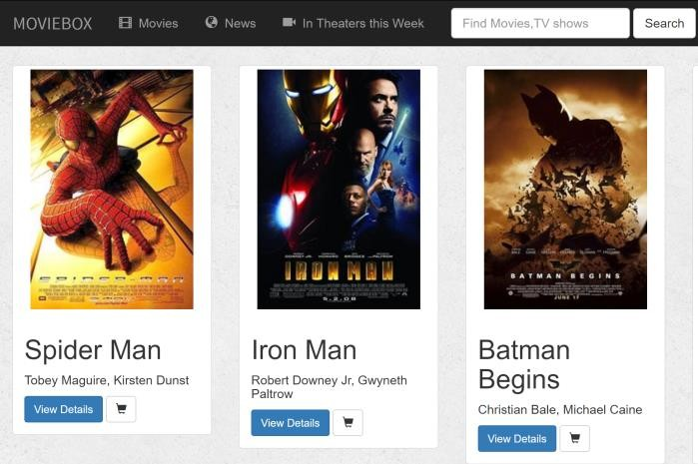
Fig: Home Page

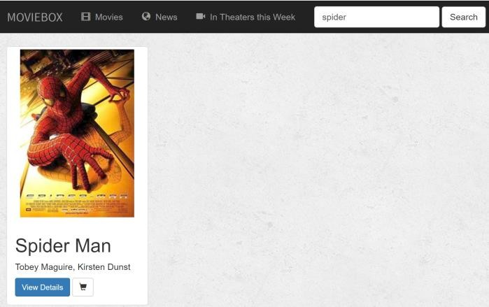
Fig: Demonstration of Search
User before payment must review the cart and checkout.

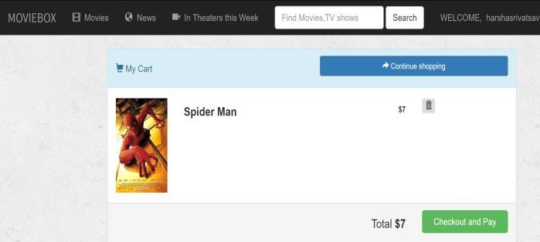
Fig: Checkout

E. PAYMENT:
After checking out, user must enter his Credit Card details.

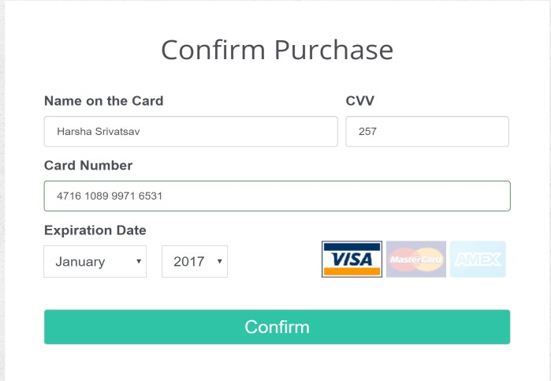Fig: Payment

F. ADMIN:
Admin has dedicated section to handle the movie data and to control users.

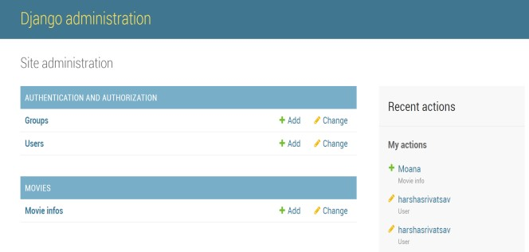Fig: Admin View

VI. EXISTING VS PROPOSED SYSTEMS
From the above demonstration, we might have come to an understanding that the proposed system has a significant edge over existing system in terms of almost every aspect.

SCENARIO | EXISTING PROPOSED
SECURITY | NO YES
REAL TIME | NO YES
EFFICIENCY | NO YES
UI | NO YES
COST EFFECT | NO YES
Fig: Comparison Table

VII. CONCLUSION

With technology developing at a rapid pace, there is a definite need for a more reliable, digitized online shopping system that is secure. Online Shopping is a different experience and you can make the shopping creative over the internet as you get used to it. There can be lot of apprehensions about online shopping when you get in to it for the first time. As you experience more and more of it those apprehensions get disappeared slowly. Remember that if you stick to the basics, online shopping become more enjoyable and easier than real- world shopping. Meeting the user’s requirements, a beautifully crafted UI (User Interface) has been developed that is hassle free. This system brings a positive experience to users who wants to shop their favorite movies with much ease. [10]

REFERENCES

[1] “The benefits of web-based applications,” The benefits of web-based applications. [Online]. Available: http://www.magicwebsolutions.co.uk/blog/the-benefits- of-web-based-applications.htm. [Accessed: 09-Dec-
2016].

[2] “How has this term impacted your life?,” BusinessDictionary.com. [Online]. Available: http://www.businessdictionary.com/definition/online- shopping.html. [Accessed: 09-Dec-2016].

[3] “Background to the Study,” Scribd. [Online]. Available: https://www.scribd.com/doc/31988584/Background-to- the-Study. [Accessed: 09-Dec-2016].

[4] “// Encyclopedia,” Web application Definition from PC Magazine Encyclopedia. [Online]. Available: http://www.pcmag.com/encyclopedia/term/54272/web- application. [Accessed: 09-Dec-2016].

[5] “Online Vs. Traditional Shopping,” Online Vs. Traditional Shopping. [Online]. Available: http://www.shoppingnavigator.co.uk/benefits-of-online- shopping.php. [Accessed: 09-Dec-2016].

[6] “Shopping-Cart-Expedition,” Shopping-Cart- Expedition. [Online]. Available: http://www.slideshare.net/baldrick98007/shopping-cart- expedition-ii. [Accessed: 09-Dec-2016]

[7] “Shopping-Cart-Expedition,” Shopping-Cart- Expedition. [Online]. Available: http://www.slideshare.net/baldrick98007/shopping-cart- expedition-ii. [Accessed: 09-Dec-2016]

[8] “Online Vs. Traditional Shopping,” Online Vs. Traditional Shopping. [Online]. Available: http://www.shoppingnavigator.co.uk/benefits-of-online- shopping.php. [Accessed: 09-Dec-2016].

[9] “Video Rental System Software Requirements Specification (partial example),” vrsSRSExample.html. [Online]. Available: http://www.cs.fsu.edu/~baker/swe1/restricted/templates/ vrsSRSExample.html. [Accessed: 09-Dec-2016].

[10] “Conclusion for Online Shopping Project,” Conclusion for Online Shopping Project. [Online]. Available: http://www.answers.com/Q/What_is_a_conclusion_for_ online_shopping_project#slide=7.[Accessed: 09-Dec-
2016].

